Circumfix

What is Circumfix
# Source: Chatgpt (GPT-4-turbo) at [7/29/2025]
A circumfix is a type of affix that is split into two parts: one part is attached to the beginning of a root, and the other to the end. Together, they function as a single unit to alter the meaning or grammatical function of the word.

🔹 Definition of Circumfix:
# Source: Chatgpt (GPT-4-turbo) at [7/29/2025]
A circumfix is a discontinuous affix that wraps around the root or base word—one part is prefixed, and the other is suffixed. The two parts must function together as a single morphological unit.

🔹 Examples of Circumfixes:

1. In Other Languages (Common Use):
# Source: Chatgpt (GPT-4-turbo) at [7/29/2025]
- German:
  - Root: lieb ("love")
  - Circumfix: ge– + –t
  - Word: geliebt ("loved" – past participle)
- Malay:
  - Root: ajar ("teach")
  - Circumfix: ke– + –an
  - Word: kebijaksanaan ("wisdom")

2. In English (Very Rare / Argued Cases):
# Source: Chatgpt (GPT-4-turbo) at [7/29/2025]
- English does not productively use circumfixes. Some analyses claim that past participle formation (e.g., enlightened, emboldened) may involve circumfix-like structures (en– + –ed), but this is not generally accepted as a true circumfix.

🔹 Features of Circumfixes:
# Source: Chatgpt (GPT-4-turbo) at [7/29/2025]
- ✅ Appear around the root: part before, part after.
- ✅ Function as one unit (not separate affixes).
- ✅ Common in non-English languages, especially Germanic, Austronesian, and African languages.
- ❌ Not productive in modern English.

🔹 Circumfix vs Other Affixes:
# Source: Chatgpt (GPT-4-turbo) at [7/29/2025]
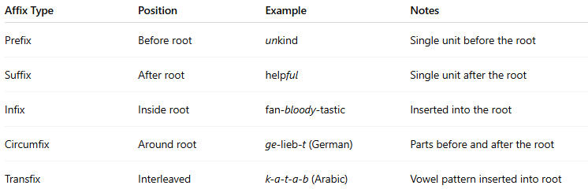
Affix Type | Position | Example | Notes
Prefix | Before root | unkind | Single unit before the root
Suffix | After root | helpful | Single unit after the root
Infix | Inside root | fan-bloody-tastic | Inserted into the root
Circumfix | Around root | ge-lieb-t (German) | Parts before and after the root
Transfix | Interleaved | k-a-t-a-b (Arabic) | Vowel pattern inserted into root

🔹 Summary:
# Source: Chatgpt (GPT-4-turbo) at [7/29/2025]
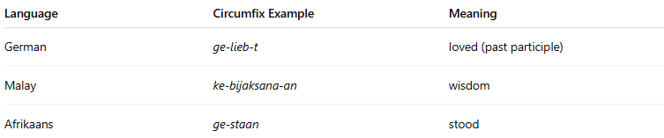
Language | Circumfix Example | Meaning
German | ge-lieb-t | loved (past participle)
Malay | ke-bijaksana-an | wisdom
Afrikaans | ge-staan | stood

